0-1 Knapsack

Problem
Given an array of items with their {weight, value}, and a knapsack (bori) with weight W. Find the maximum value of items that can be stolen and put into a knapsack.
Note: We either have to pick full item or no item, we cannot take partial items.

Example:
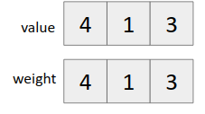
W = 50 kg

Possible combinations that we can steal:
{15, 30} {40}
V = 60 + 100 = 160 V = 150

It is important to note that we cannot apply greedy technique here as items are indivisible.

Way of thinking:
We iterate from left to right in the items array. For each item we have 2 choices
- Take it ➤ Remaining capacity of the knapsack decreases.
- Don’t take it ➤ Capacity of knapsack remains the same.

Let f(n, W) = denotes the maximum value of items that we can pick till item n and current capacity of knapsack W.

Therefore f(n, W) = max( f(n-1, W), f(n-1, W-weight[n]) + value[n] )
Since we can represent it as a recurrence relation, it follows optimal substructure property.

Let us check if it follows the overlapping subproblem property also?

Example
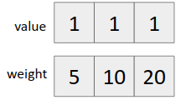
W = 2kg
Recursion tree for the above example

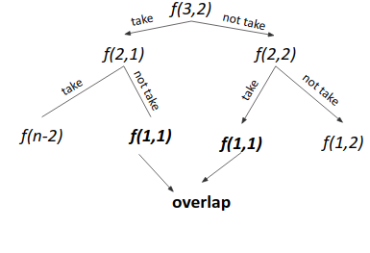
Since f(1,1) repeats ➤ It follows overlapping subproblem property also.

Hence it can be solved using dynamic programming.

Brute force Approach
- Make all subsequences and pick the one with maximum value, which fits the constraints of knapsack.
Time Complexity: O(2^{n})
where n is the number of items

Optimal Solution (Using dynamic programming)
Approach 1 (Memoization)
- Write the recursive solution.
- Memoize it.

Approach 2 (Tabulation)
- For each item, compute the answer for every weight from 0 to W.
- Use recurrence of taking and not taking
dp[n][w] = max(dp[n-1][w], dp[n-1][w-wt[n]] + val[n])
provided w-wt[n] is non negative
- Output the answer (dp[n][w])

Time Complexity: 0(n*W)

Code (Memoization)
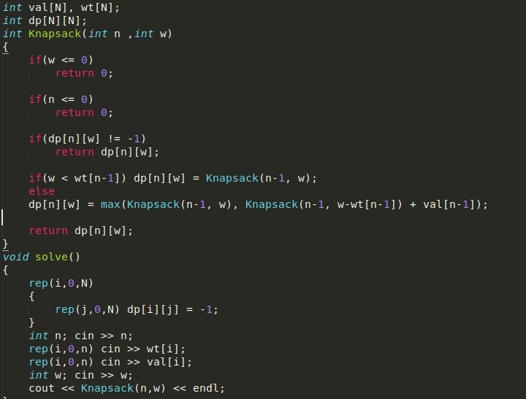

Code (Iterative)
